JOIN US FOR A SCREENING OF
“They journeyed across the Pacific, seeking better lives for themselves and for their children. Many arrived at Angel Island, weary but hopeful only to be unjustly confined for months and in some cases years. As we remember their struggle, we honor all who have been drawn to America by dreams of limitless opportunity.”-President Barack Obama, January 24, 2010

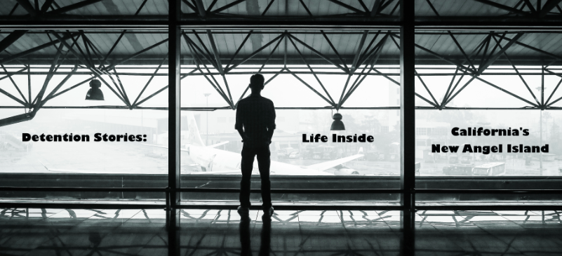
DETENTION STORIES: LIFE INSIDE CALIFORNIA’S NEW ANGEL ISLAND

Community Initiatives for Visiting Immigrants in Confinement (CIVIC) is proud to release Detention Stories: Life Inside California’s New Angel Island, a documentary film series that explores the social and cultural world inside California’s immigration detention centers through individuals who are in the best position to describe it: men and women in detention. Come learn about the history of immigration detention in California from the early 1900s to the present.

Details:
Date:
Location:

Presented by:
Community Initiatives for Visiting Immigrants in Confinement in partnership with NAME OF YOUR GROUP. This documentary film series was made possible with support from Cal Humanities, in partnership with the National Endowment for the Humanities (NEH). Any views, findings, conclusions, or recommendations expressed here do not necessarily represent those of Cal Humanities or NEH. Experience more at calhum.org and endisolation.org.

Agenda:

Please ensure that all community screenings of this series are free.

A tax-deductible donation to CIVIC is highly suggested.
www.endisolation.org/donate

